IoWA-PCIT Training Part I and II

April 27th-May 1st, 2020 (Part I)

September 21st-23rd, 2020 (Part II)

Mid-Iowa Family Therapy Clinic, Inc
Windsor Heights, Iowa

Julie Mertz, LMFT and Katie Obert, LMFT

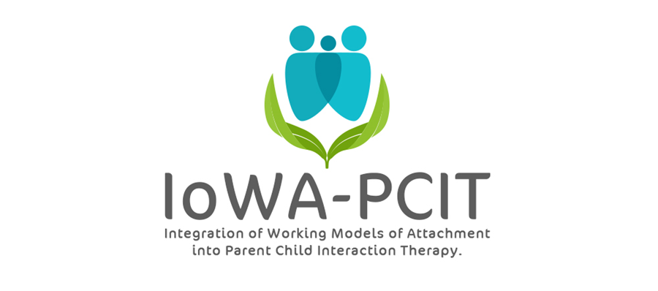

Description of training: This year long training provides mental health providers with the training and consultation needed to deliver IoWA-PCIT. Providers learn: 1) to administer and interpret standardized assessments of parent-child interaction based on attachment and behavioral principles; 2) to administer and interpret standardized assessments of disruptive behavior; 3) to coach parents in Child-Directed Interaction (CDI) and Parent-Directed Interaction (PDI). Providers begin delivering IoWA-PCIT following Part l training (April 27 to May 1, 2020). Monthly consultation calls and Part ll training (September 21 to 23, 2020) provides support for implementation of IoWA-PCIT and tailoring coaching based on attachment, presenting problem, and other aspects of patient population.

About the trainers: Julie Mertz and Katie Obert are both Licensed Marriage and Family Therapists. They have been working in the mental health/human services field for over 10 years. Both were trained in IoWA- PCIT (Integration of Working Models of Attachment into Parent Child Interaction Therapy) in 2016 by the creator and founder of IoWa- PCIT, Dr. Beth Troutman at the University of Iowa. After seeing great outcomes with this model in our practice, and the continued need for more providers, we decided to obtain additional training with Dr. Troutman to become trainers in 2019.

IoWA-PCIT Training Part I and II
Mid-Iowa Family Therapy Clinic, Inc.
6900 University Ave
Ste 115
Windsor Heights, IA 50324
PLEASE PRINT LEGIBLY—THANK YOU!
Name:
Credentials (e.g. LISW, LMHC, MSW, PhD):
Organization:
Address:
City: State: Zip:
Day Phone: Fax:
Email:
REGISTRATION FEE: $4000 per person | PAYMENT
- Includes:  - 5 all day sessions on April 27, 28, 29, 30 and May 1 2020; 3 all day sessions on September 21, 22 and 23, 2020; monthly consultation calls from May 2020 through May 2021.  - Conference registration fees do not include lunch, accommodations, or parking. Arrangements for hotel accommodations are the responsibility of each individual participant. | - Registration is complete when form and fees are received. Refunds will not be available for registered participants.  - Mail registration and payment (check or money order) to:  Mid-Iowa Family Therapy Clinic, Inc.  20244 141st Street  Perry, IA 50220  - Check payable to: ITPS
MEETING LOCATION
All meetings will be held at the Mid-Iowa Family Therapy Clinic office in Windsor Heights. For questions contact Julie Mertz or Katie Obert at: 515-254-1556; julie.mertz@miftc.com or katie.obert@miftc.com
CEUS
Documentation of hours of attendance will be available. Full time attendance for the 5-day session (Part I) is intended to meet the criteria for 40 hours of continuing education for Behavioral Science; Psychology; and Social Work. Full time attendance for the 3-day session (Part II) is intended to meet the criteria for 24 hours of continuing education. Full Sign-up sheets and information will be available on site.

