IoWA-PCIT Training Part I and II

November 9th-13th, 2020 (Part I)

May 18th- May 20th, 2021 (Part II)

Mid-Iowa Family Therapy Clinic, Inc
Windsor Heights, Iowa

Julie Mertz, LMFT and Katie Obert, LMFT

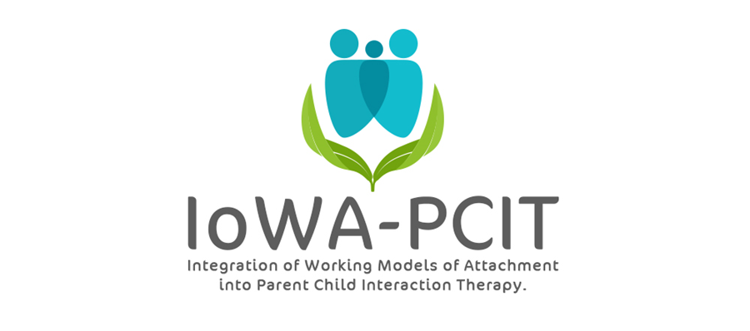

Description of training: This year long training provides mental health providers with the training and consultation needed to deliver IoWA-PCIT. Providers learn: 1) to administer and interpret standardized assessments of parent-child interaction based on attachment and behavioral principles; 2) to administer and interpret standardized assessments of disruptive behavior; 3) to coach parents in Child-Directed Interaction (CDI) and Parent-Directed Interaction (PDI). Providers begin delivering IoWA-PCIT following Part l training (November 9th – November 13th, 2020). Monthly consultation calls and Part ll training (May 18th-May 20th, 2021) provides support for implementation of IoWA-PCIT and tailoring coaching based on attachment, presenting problem, and other aspects of patient population. Due to COVID-19, this training has moved exclusively online.

About the trainers: Julie Mertz and Katie Obert are both Licensed Marriage and Family Therapists. They have been working in the mental health/human services field for over 10 years. Both were trained in IoWA- PCIT (Integration of Working Models of Attachment into Parent Child Interaction Therapy) in 2016 by the creator and founder of IoWa- PCIT, Dr. Beth Troutman at the University of Iowa. After seeing great outcomes with this model in our practice, and the continued need for more providers, we decided to obtain additional training with Dr. Troutman to become trainers in 2019.

IoWA-PCIT Training Part I and II
Institute for Therapy and Psychological Solutions
6900 University Ave
Ste 115
Windsor Heights, IA 50324
PLEASE PRINT LEGIBLY—THANK YOU!
Name:
Credentials (e.g. LISW, LMHC, LMFT, MSW, PhD):
Organization:
Address:
City: State: Zip:
Day Phone: Fax:
Email:
REGISTRATION FEE: $4000 per person | PAYMENT
- Includes:  - 5 all day sessions on November 9, 10, 11, 12 and 13, 2020; 3 all day sessions on May 18, 19 and 20, 2021; monthly consultation calls from November 2020 through November 2021.  - Scholarships are available upon request, | - Registration is complete when form and fees are received. Refunds will not be available for registered participants.  - Mail registration and payment (check or money order) to:  Institute for Therapy and Psychological Solutions, Inc.  P.O. Box 416  Perry, IA 50220  - Check payable to: ITPS
MEETING LOCATION
All meetings will be held via a virtual platform. For questions contact Julie Mertz or Katie Obert at: 515-254-1556; julie.mertz@miftc.com or katie.obert@miftc.com
CEUS
Documentation of hours of attendance will be available. Full time attendance for the 5-day session (Part I) is intended to meet the criteria for 40 hours of continuing education for Behavioral Science; Psychology; and Social Work. Full time attendance for the 3-day session (Part II) is intended to meet the criteria for 24 hours of continuing education. Full Sign-up sheets and information will be available on site.

